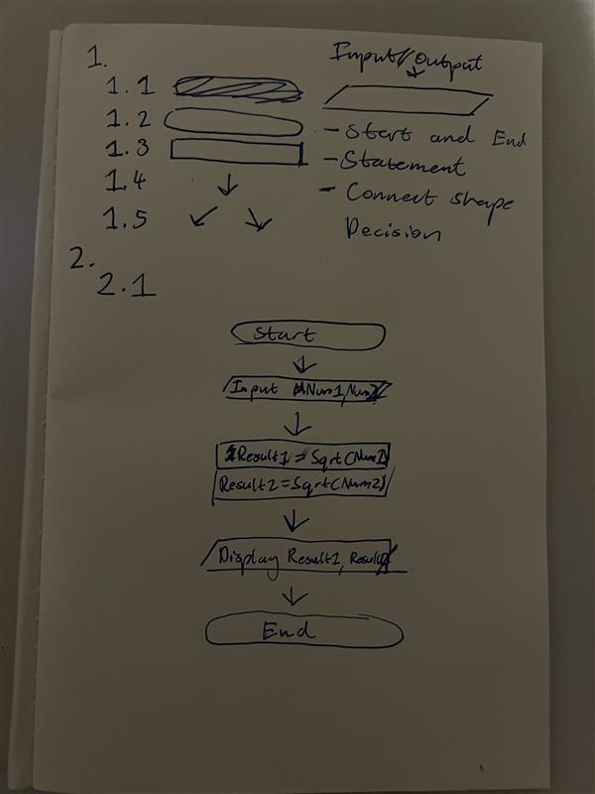
begin
input num1, num2
result1 -> .sqrt(num1)
resul2 -> .sqrt(num2)
display result1
display result2
end
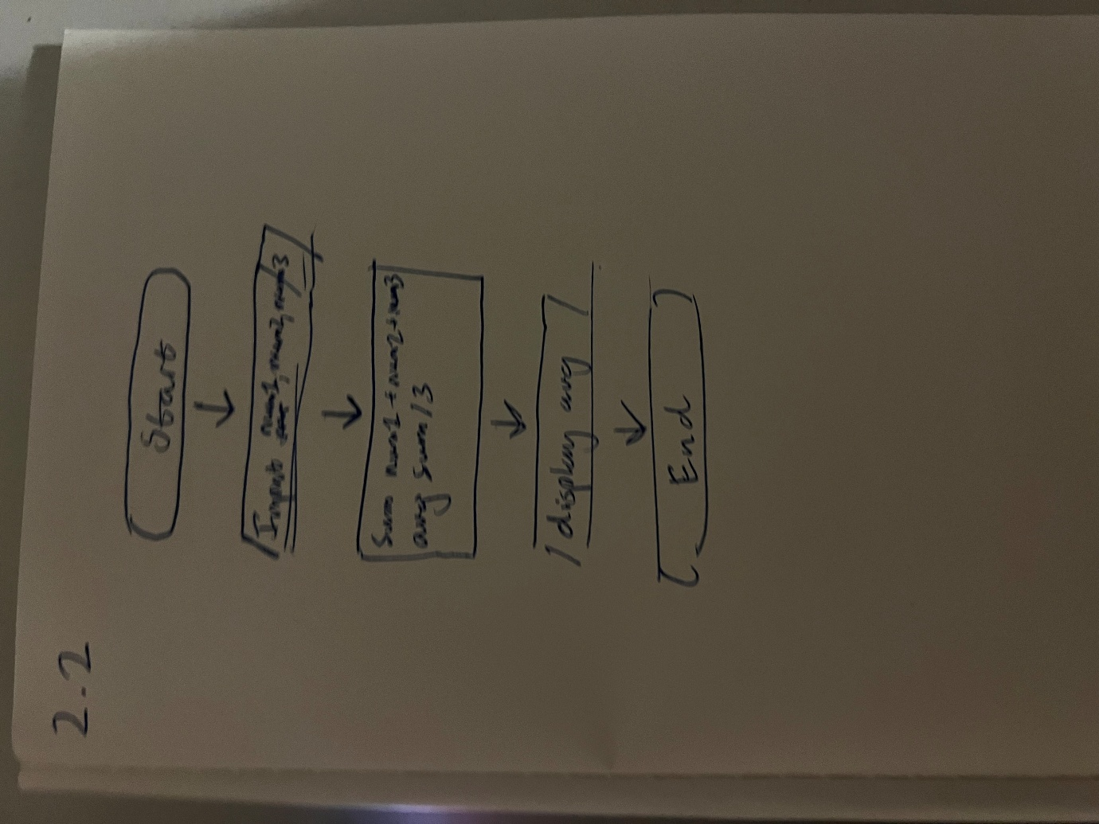
Begin
Input num1, num2, num3
Sum -> num1 + num2 + num3
Avg -> sum/3
Display avg
End
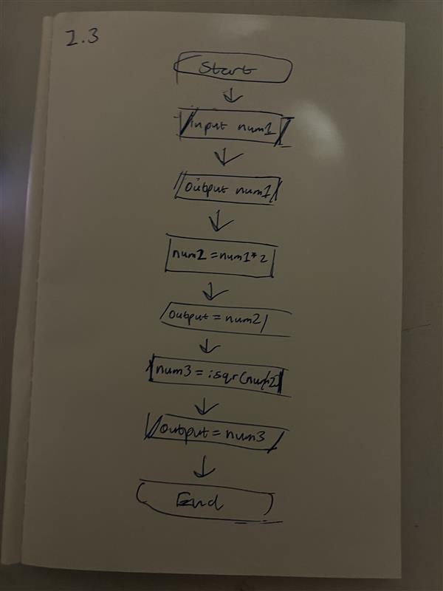
Begin
Input num1
Display num1
Num2 -> num1*2
Display num2
Num3 -> .sqr(num2)
Display num3
End
3
3.1
Begin
Input x, y, z
Sum -> x + y + z
Avg -> sum/3
Display avg
End
3.2
Begin
Input name, hours, rate
Pay -> hours * rate
Display name
Display pay
End
